**DAILY ONLINE ACTIVITIES SUMMARY**

|  |  |  |  |  |  |  |  |  |
| --- | --- | --- | --- | --- | --- | --- | --- | --- |
| **Date:** | **7-06-2020** | | | | | **Name:** | **Javahar.S.Goutham** | |
| **Sem & Sec** | **7 B sec** | | | | | **USN:** | **4AL16CS132** | |
| **Online Test Summary** | | | | | | | | |
| **Subject** | | **SMS(OS)** | | | | | | |
| **Max. Marks** | | **60** | | **Score** | | | **60** | |
| **Certification Course Summary** | | | | | | | | |
| **Course** | **Introduction to ethical hackin(completed)**  **Rpa(completd)** | | | | | | | |
| **Certificate Provider** | | | **Great Learning**  **guvi** | | **Duration** | | | **9hrs** |
| **Coding Challenges** | | | | | | | | |
| **Problem Statement**: 1. Python program to combine the strings.  **2.** Write a Java program to implement Queue Using Array And Class. | | | | | | | | |
| **Status: YES, Completed all Programs.** | | | | | | | | |
| **Uploaded the report in Github** | | | | | **YES** | | | |
| **If yes Repository name** | | | | | https://github.com/alvas-education-foundation/Goutham-dotcom | | | |

Online Test Details: (Attach the snapshot and briefly write the report for the same)

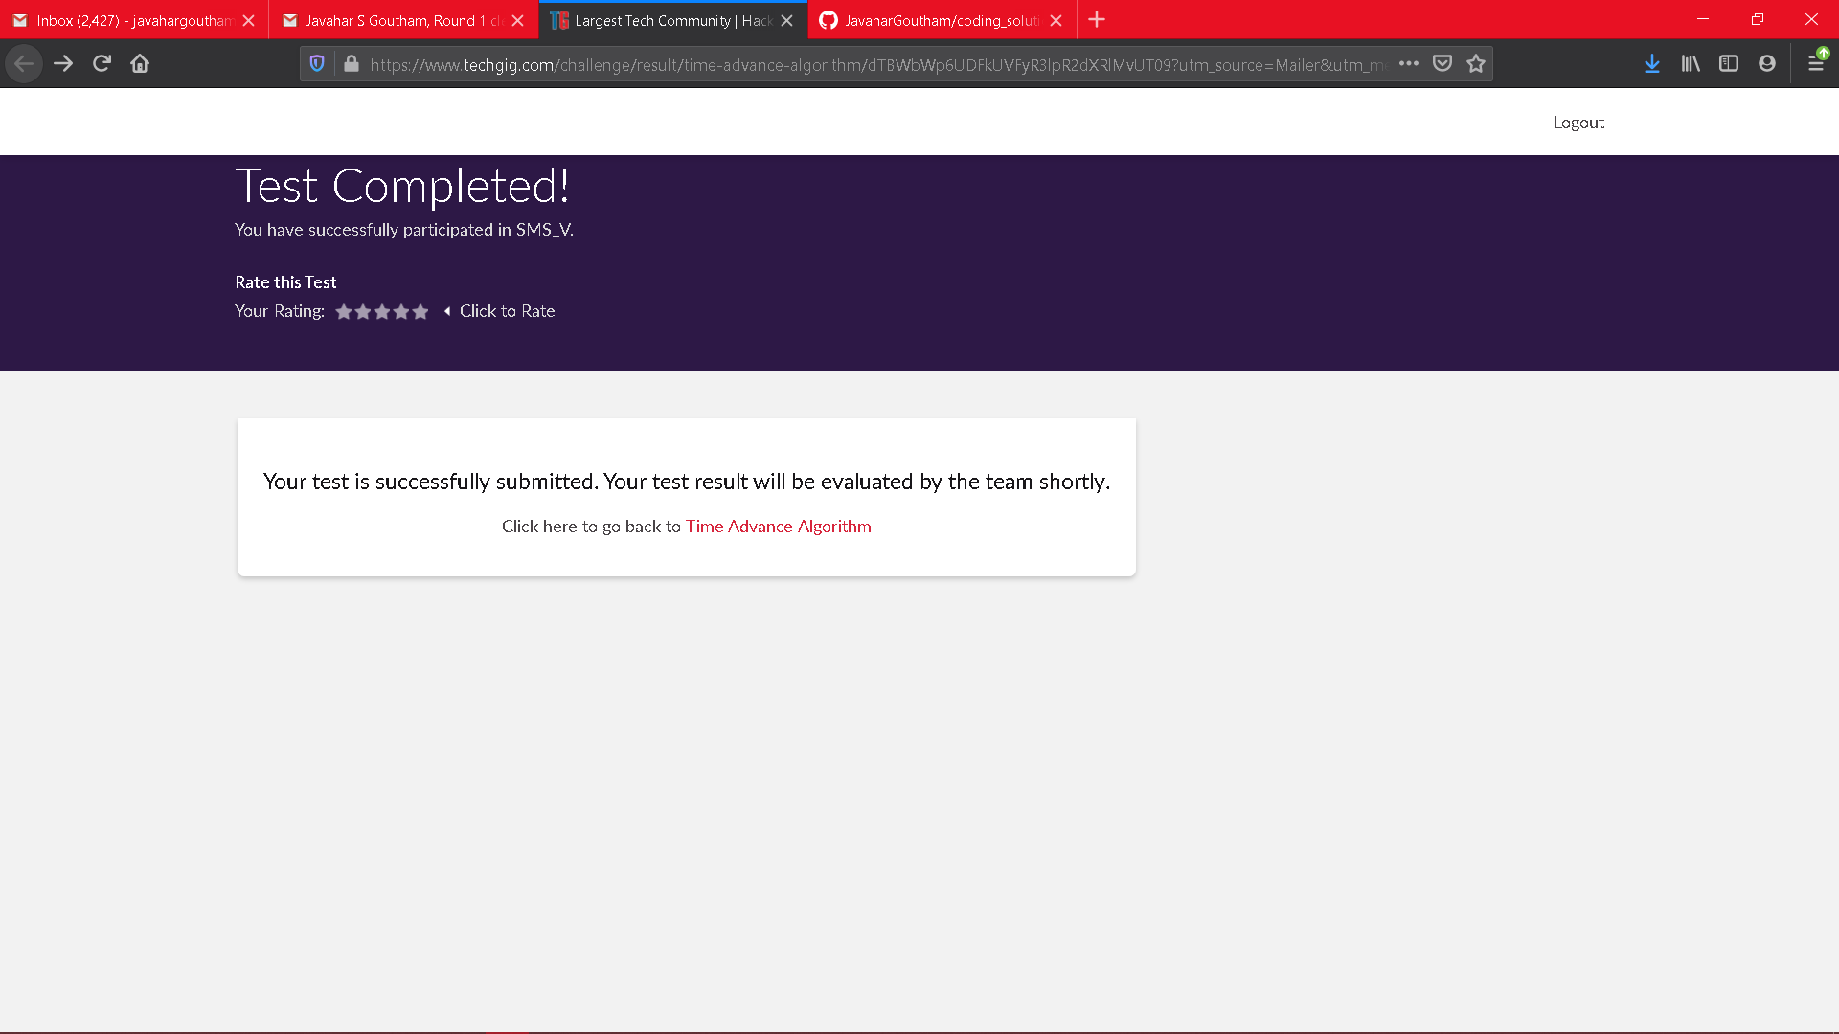

Scored 60 out of 60 in SMS test

Certification Course Details: (Attach the snapshot and briefly write the report for the same)

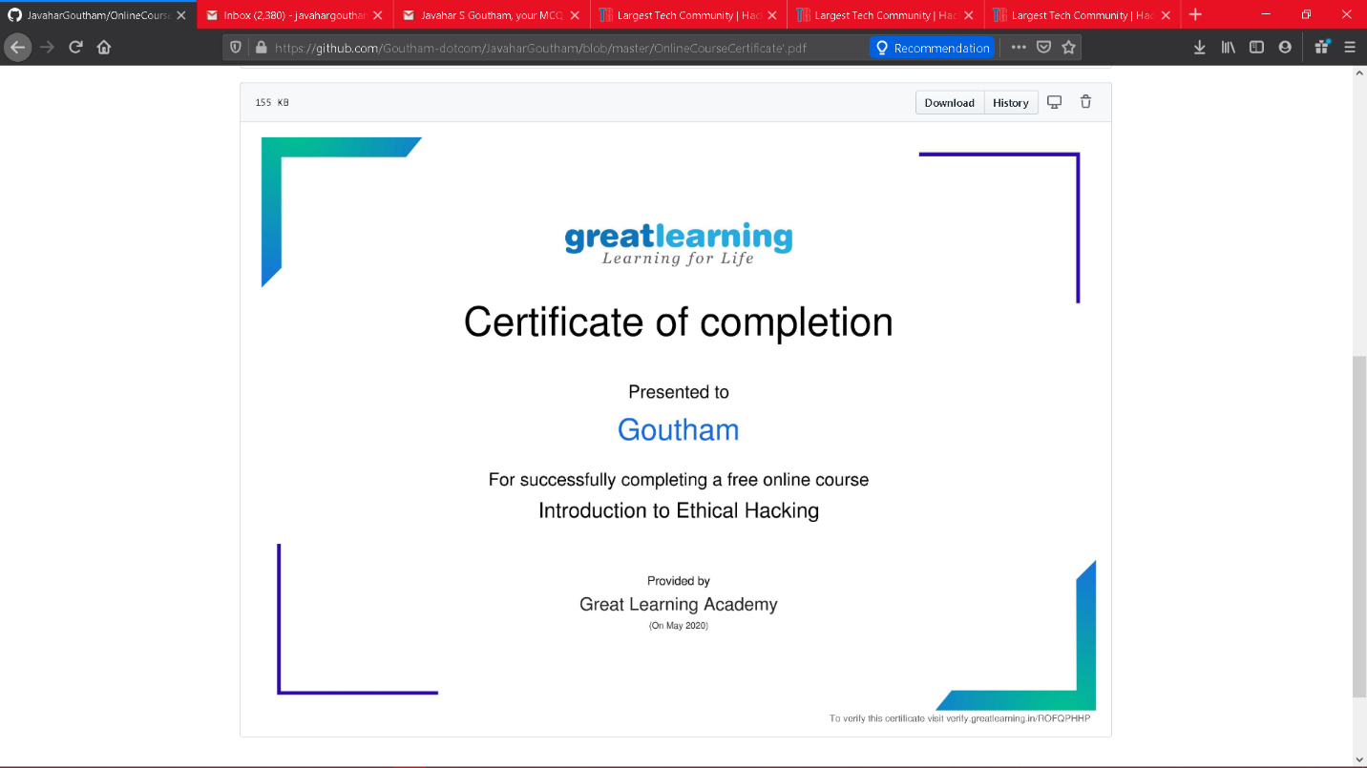

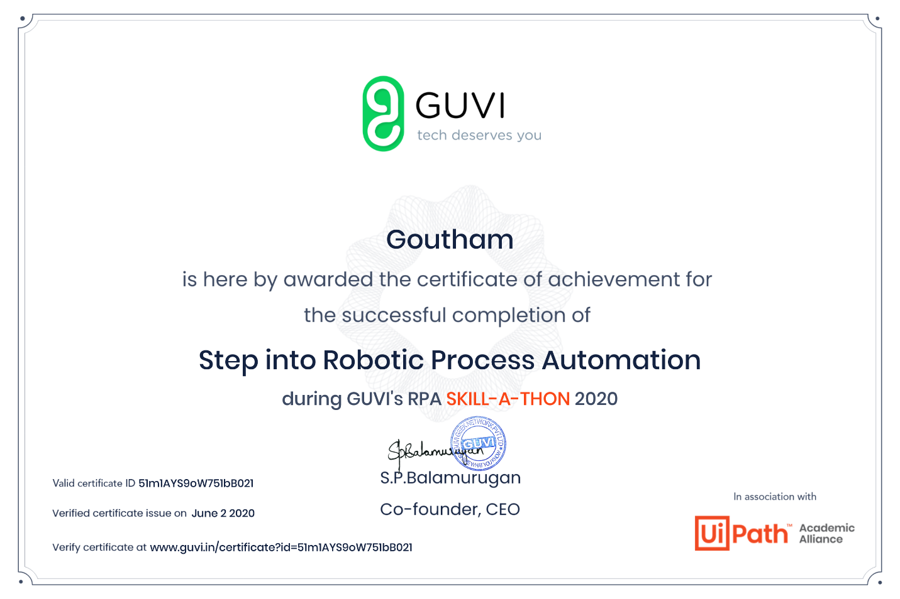

Coding Challenges Details: (Attach the snapshot and briefly write the report for the same)

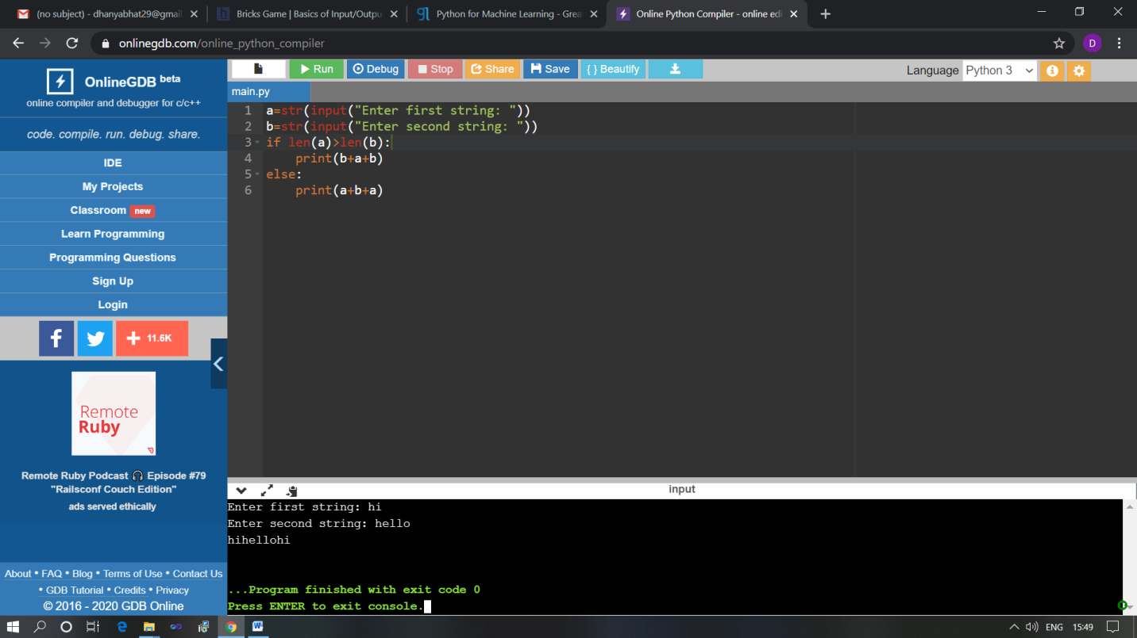

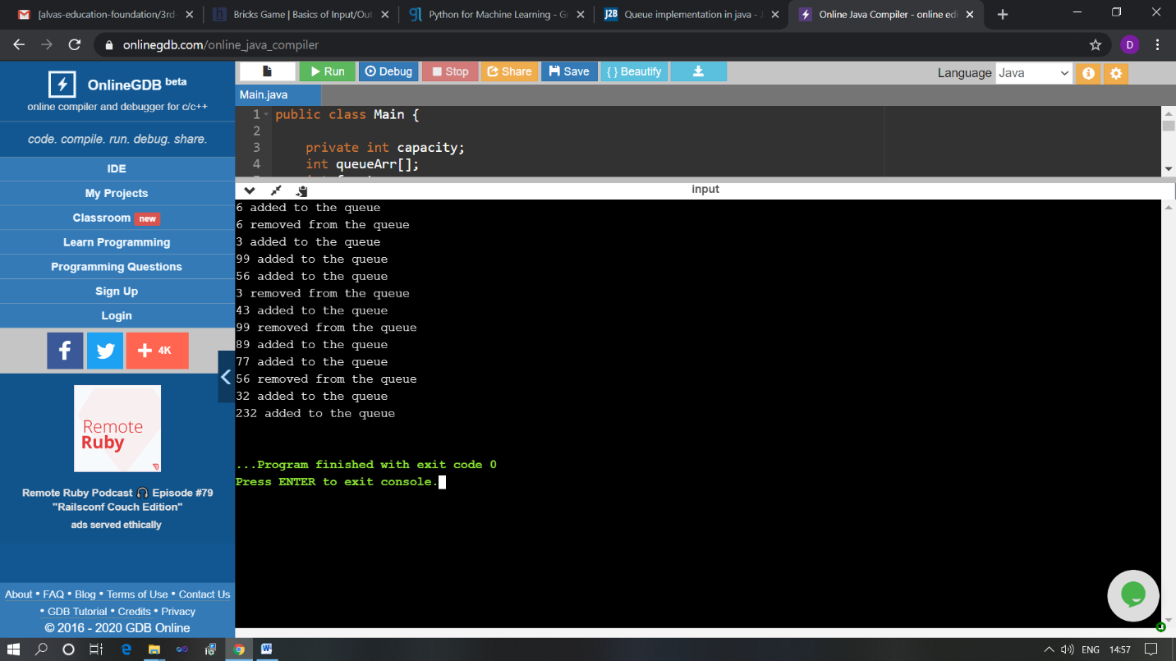

The above Programs were written and executed and the output of the same is displayed above. The code for those 2 programs have been uploaded to the github repository and the link to the same is provided on the form.